Exclusive Flying

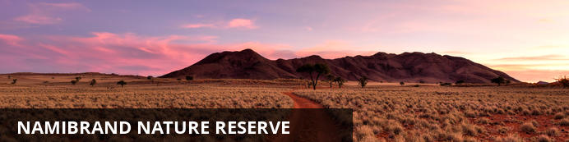
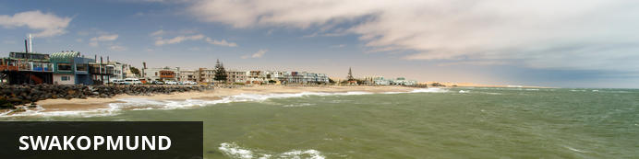
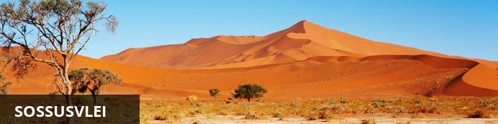
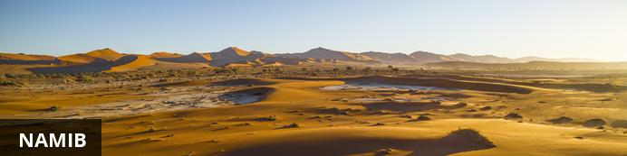
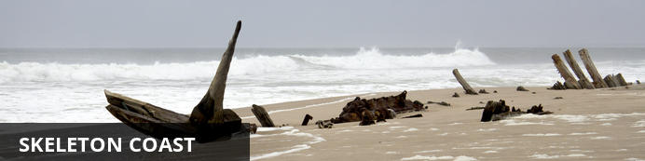
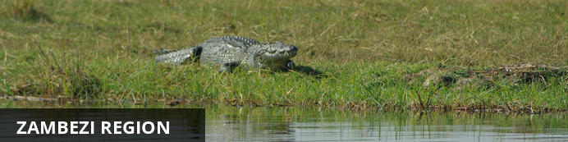
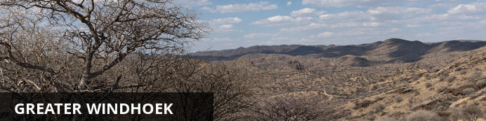

Exclusive Travel
NamibRand Nature Reserve - Swakopmund - Namib - Skeleton Coast - Zambezi Region - Greater Windhoek
10 Days / 9 Nights

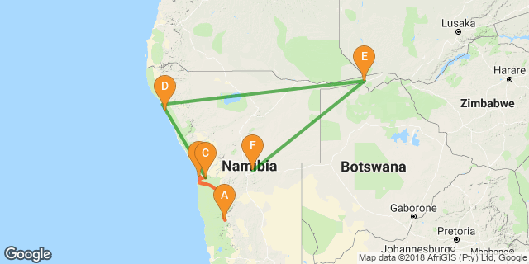

Introduction

Accommodation | Destination | Basis | Duration
andBeyond Sossusvlei Desert Lodge | NamibRand Nature Reserve | FI | 2 Nights
Strand Hotel Swakopmund | Swakopmund | B&B | 1 Night
Desert Catering - VIP Luxury Tented Camp in Moonlandscape | Namib | D, B&B | 1 Night
Skeleton Coast Shipwreck Lodge | Skeleton Coast | FI | 2 Nights
Nambwa Tented Lodge | Zambezi Region | FI | 2 Nights
Na'an ku se Lodge | Greater Windhoek | D, B&B | 1 Night

Key
B&B: Bed and Breakfast
D, B&B: Dinner, Bed and Breakfast
FI: Fully Inclusive

Price per person from NAD: 135 500.00

Day 1: andBeyond Sossusvlei Desert Lodge, NamibRand Nature Reserve

NamibRand Nature Reserve
Spanning an area of 172,200 hectares and encompassing four distinct ecosystems, the Namib Rand Reserve is among the largest privately owned game parks in Southern Africa. Founded to conserve the unique environment and wildlife species of the south-western Namib Desert, the park’s mix of dunes, mountains, rocky outcrops, sandy flats and gravel plains provides habitats for a diversity of mammals – including hyenas, jackals, foxes, antelopes and various wild cats – as well as a plethora of bird species, reptiles, insects, frogs and flora. Visitors can discover the mysterious ‘fairy circles’, which dot the landscape and sip on sundowners while watching the sunset over this unspoilt ancient landscape. Having been named Africa’s first International Dark Sky Reserve, it is one of the least light-polluted areas in the world, so don't miss this excellent star gazing opportunity.

Day Itinerary
Upon arrival at the Hosea Kutako International Airport, Abenteuer Afrika Safaris guide will be there to welcome you. Depart with the Abenteuer Afrika Safaris vehicle to Sossusvlei.

Overnight: andBeyond Sossusvlei Desert Lodge
One of the most pristine areas on Earth, the Namib Desert is a world of vast spaces, endless horizons, dramatic landscapes and jagged mountain heights. Cradled against the ancient mountains, andBeyond Sossusvlei Desert Lodge is renowned for its luxurious accommodation overlooking the starkly beautiful Namib Desert. Designed to capture the splendour and solitude of the desert, just ten stone and glass suites spread out along the curve of the escarpment, allowing absolute privacy. Each air conditioned suite is furnished to complement the majestic hues of the desert and features a private veranda, split-level bedroom and living room with fireplace, ensuite glass-encased bathroom and outdoor shower. The suites are equipped with a star-viewing skylight, discrete music system and custom-stocked personal bar. The guest area, where walls have become windows that fold away completely, boasts unimpeded desert vistas. The split-level lodge boasts a fire-lit bar, comfortable sitting room, wraparound veranda and Safari Shop. A fine selection of wines from an impressive walk-in wine cellar complements the delicious meals. Guests can escape the desert heat with a revitalising midday dip in the pool, fed by water from an underground spring. At sunset, animals are drawn to a nearby waterhole, enhancing desert sundowner drinks. A state-of-the-art observatory and resident astronomer provide insight into the magnificent constellations of Africa’s first International Dark Sky Reserve.
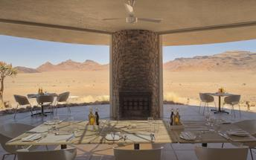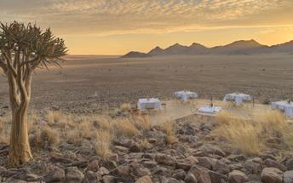

Transfers
Date | Company | Pick Up | Drop Off | Time | Vehicle
 |  | Hosea Kutako International Airport [WDH] | andBeyond Sossusvlei Desert Lodge |  | Transfer

Basis
Fully Inclusive

Day 2: andBeyond Sossusvlei Desert Lodge, NamibRand Nature Reserve

Day Itinerary
Early morning departs to Sossusvlei Dunes with Sossusvle Desert Lodge, stop at Dune 45 for a dune climbing warm up then proceed to the Dead vlei parking. Another opportunity to take up the challenge and climb the highest climb dune in Namibia, Big Daddy. the greatest award is the view into the Deadvlei from the top of Big Daddy. Descend into the vlei and spend time taking amazing photos within the vlei. after which you drive to the Sossusvlei pan then make your way to the Sesreim Canyon before you return to the Lodge.

Activities
Sossusvlei & Sesriem

Sossusvlei & Sesriem
Accompanied by your tour guide you will set off in the very early morning and drive in your tour vehicle to the Sesriem Gate, which is the entrance to the Namib Naukluft Park. Passing through the gate you will follow a 65 km long route though the National Park until you will reach a parking area. From here onwards only 4x4 vehicles can proceed through the thick sand. Therefore you will get off the tour vehicle and switch over to a 4x4 transfer shuttle, which will take you the last 5 km to the famous dunes of Sossusvlei. Enjoy the fascinating view of the dunes and the changing of shadows and colours on the sand. On our way back you may visit the Sesriem Canyon, which marks the end of this wonderful excursion. The park entrance fee and the 4x4 transfer shuttle (return) is included.

Basis
Fully Inclusive

Day 3: Strand Hotel Swakopmund, Swakopmund

Swakopmund
Germany’s North Sea and Baltic coasts transplanted onto African soil. But the city is also thoroughly African and its multidimensional appeal means that most people end up staying longer than they planned.
Palm-lined streets, seaside promenades, fine accommodation, a pleasant summer climate and decent beaches. During the summer holidays and long weekends, thousands of Namibians flock to the coast, and this human migration happens for a number of reasons; Swakopmund has a real holiday feel to it and everyone wants to be there; during the December holidays, the cool Namibian coast offers relief from the intense heat of the interior; and more importantly as far as the tourist is concerned in these modern times, Swakopmund has changed, and has become the country’s leading adrenaline destination, with a wide range of activities to suit all ages.
The area of Namib Desert around Swakopmund is named the West Coast Recreational Area and recreation is the towns number one draw card. There are countless pursuits to help you spend your time, and money. For those interested in adventure activities Swakopmund offers sandboarding, quad biking, dune carting, parachuting, hot air ballooning, shark fishing, deep sea fishing and beach angling to name but a few. For the more sedentary there are restaurants, cafes, art galleries, the Swakopmund Museum, a snake park and aquarium.
Buildings and monuments of note in Swakopmund include the Hohenzollern Building, the Marine memorial, the War memorial in memory of those killed in World War 2, Princess Rupprecht House originally a military hospital now a private guest house, the Kaserne buildings that originally served as a barracks and is of a similar design to the Alte Feste in Windhoek and Fort Namutoni in Etosha. The old Swakopmund Prison is still fully operational and provides budget accommodation for the criminal fraternity of the Namibian coast.
The Swakopmund Railway station was completed in 1901 and now houses the Swakopmund Hotel, while the bells of the Deutsche Evangelical Church were imported from Germany. Standing close to the State House (Kaiserliches Bezirksgericht) is the Swakopmund Lighthouse at just over 20 meters it has been functional since 1902.
The main beach area is called the Mole, and is the result of a largely unsuccessful attempt to construct the artificial harbor (as South Africa owned the only natural harbor in the area at Walvis Bay). The town’s most iconic symbol is the Swakopmund jetty, initially used as mooring for ships it later became a popular are for anglers and walkers, it has fallen into disrepair on numerous occasions and has been subject to several attempts to rescue it from complete dereliction. Recently large scale work has been completed on the jetty which now proudly boasts a small restaurant and bar area.
True to its German traditions early mornings and evenings in Swakopmund can be cold throughout the year, as the cold Atlantic Ocean meeting the Namib Desert creates a fog bank. This coolness is often a relief from the heat of the rest of Namibia, but does mean that Swakopmund is not the tropical sunbathing mecca that most people imagine.

Day Itinerary
After the optional Hot Air Balloon excursion, depart to Swakopmund via the Kuiseb and Gaub Pass, reaching Walvis Bay, you will have a quick stop at the Lagoon and if lucky Millions of Flamingos will be there.

Overnight: Strand Hotel Swakopmund
With its extensive, unique and creatively entertaining Restaurants, Bars, Deli, Lobby-Lounge, Sea Facing Terraces, Beach Kiosk and state of the art Conference & Banqueting Center, all set on the Mole, a historic and iconic site surrounded by Ocean on three sides, the Strand Hotel Swakopmund is a social epicenter and destination in itself for all visitors to and residents of Swakopmund. Its architectural inspiration finds its roots deep in Namibian German history and reflects this in a tasteful contemporary manner. The interiors are residential in nature, and the brief to all designers involved was to create a non-hotel, hotel. One as charming and welcoming as the town it is located in. Simply very warm and comfortable, and as they say in German: “gemütlich” providing a genuine “sense-of-place” atmosphere adding to any Namibian visit. Arriving at the Strand is a dramatic experience as one passes through its 13m high and 9m wide Ocean View Atrium which travels right through the Hotel offering sea views at either end. Off this Atrium Lobby is Reception, consisting of three individual desks and an inviting open fireplace which rounds off the residential feel and warm welcome.
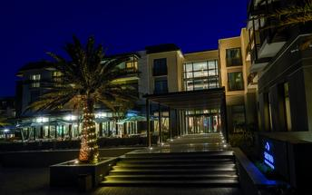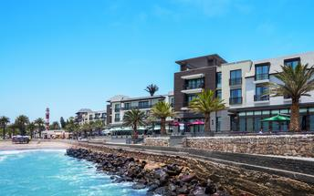

Activities
Walvis Bay Lagoon

Optional
Namib Sky Balloon Safaris

Walvis Bay Lagoon
Walvis Bay’s calm natural lagoon is a twitcher’s paradise, teeming with roughly 50 species of seabirds, including vivid flocks of flamingos, bulky-billed pelicans and glossy black cormorants. It’s also a popular spot for windsurfing, kitesurfing and kayaking, while the promenade stretching for three kilometres along the water’s edge is a great place for a scenic stroll.

Namib Sky Balloon Safaris
Situated in the heart of the Namib Naukluft Park, Sossusvlei, one of the most fascinating landscapes in Namibia, is a photographer’s dream. Gigantic orange dunes, dramatic shadows, undulating plains and rocky mountains create a magical kaleidoscope of colours and shapes. To the east, Namib Rand Nature Reserve vast sandy plains are surrounded by towering granite mountains and rolling dunes. Here, in the oldest desert on the planet, amazingly adapted animals and plants come together to form one of the most visually stunning ecosystems in the world. And truly the best way to experience the heart of the Namib desert is with a hot air balloon safari. Watching the spectacular sunrise over this magnificent landscape from a silent hot air balloon is the experience of a lifetime, never to be forgotten At landing, you come back to earth with an “Out Of Africa” style Champagne breakfast set up in the middle of nowhere. Your pilot will present you with a flight certificate before you take a leisurely nature drive back to the pick-up point.

Transfers
Date | Company | Pick Up | Drop Off | Time | Vehicle
 |  | andBeyond Sossusvlei Desert Lodge | Strand Hotel Swakopmund |  | Transfer

Basis
Bed & Breakfast

Day 4: Desert Catering - VIP Luxury Tented Camp in Moonlandscape, Namib

Namib
The Namib is the world’s oldest desert, and although it stretches along the entire length of Namibia’s coastline, the Namib commonly refers to the vast sea of sand from Luderitz to Swakopmund. For a big sandy desert the scenery is remarkably varied, with the giant red dunes of Sossusvlei being the most famous part. Because of how old it is the Namib is home to numerous species that don’t occur elsewhere and although no humans live in the desert an amazing array of flora and fauna manages to survive here. Famous species include the Welwitschia – a living fossil plant, endemic chameleons, fur seals along the coast, brown hyenas, jackals and remarkably one of Africa’s largest antelope the Gemsbok. The name Namib is of Nama origin and means "vast place" and vast it certainly is.

Day Itinerary
After optional excursions within Swakopmund depart into the Moonlandscape for the night under the stars. Moonlandscape is one of the oldest pieces of the crust of the earth in its present form.

Consultant Notes
No Notes Available

Overnight: Desert Catering - VIP Luxury Tented Camp in Moonlandscape
DESERT CATERING - VIP LUXURY TENTED CAMP IN MOONLANDSCAPE

Optional
Desert Explorers - 90 Minutes Quad Biking at Desert Explorers
Desert Explorers - 3 Hour Quad Biking & Sand Boarding Combo Combo
Tommy’s Tours and Safaris Living Desert Tour
Catamaran Charters

Desert Explorers - 90 Minutes Quad Biking at Desert Explorers
DESERT EXPLORERS - 90 MINUTES QUAD BIKING AT DESERT EXPLORERS

Desert Explorers - 3 Hour Quad Biking & Sand Boarding Combo Combo
Experience the sheer thrill of riding a quad bike through Namibia's boundless expanse of shifting sand dunes. After the engines are revved up and ready to roll, an experienced guide will lead visitors through the mouth of the Swakopmund River into the dune belt to feel the freedom of riding through one of nature's great wildernesses.

Tommy’s Tours and Safaris Living Desert Tour
The Living Desert Tour, originally developed by Tommy himself in the 1990’s, is a unique 4x4 adventure drive through the dunes outside Swakopmund, Namibia. Just the drive in the dunes is an amazing experience, but Tommy will show you a lot more than sand. The tour takes you from the vegetated, life-rich eastern side of the dunes, right through the dunes to the Atlantic Ocean on the western side of the dune belt.

Catamaran Charters
The Catamaran Charters Team invites you aboard the 45ft Royal Cape Sailing Catamaran Silverwind, or the 60ft Simon Sailing Catamaran Silversand, or the 40ft Admiral Motorised Catamaran Silvermoon, to enjoy an adventure packed tour to Pelican Point and Walvis Bay’s beautiful bay area. The chances of encountering dolphins, whales, turtles, seals and Mola Mola (sunfish) make the search for the marine big 5 and adventurous tour by enjoying sparkling wine, fresh oysters and other mouth-watering snacks aboard the spacious and comfortable catamarans.

Transfers
Date | Company | Pick Up | Drop Off | Time | Vehicle
 |  | Strand Hotel Swakopmund | Desert Catering - VIP Luxury Tented Camp in Moonlandscape |  | Transfer

Basis
Dinner, Bed and Breakfast

Day 5: Skeleton Coast Shipwreck Lodge, Skeleton Coast

Skeleton Coast
Known by the Bushmen as the "land God made in anger" the Skeleton Coast is remoteness at its best. Thousands of miles of sandy desert dotted with shipwrecks meet with the cold waters on the Atlantic and somehow an amazing array of wildlife and flora manages to survive in this harsh but beautiful environment.

Day Itinerary
After an fresh breakfst in the Moonlandscape, you will be transferred to the Swakopmund Airport for your flight into the Northern Skeleton Coast National Park.

Overnight: Skeleton Coast Shipwreck Lodge
The lodge will be located in the famous Skeleton Coast Central Concession between the Hoarusib and Hoanib Rivers in the Skeleton Coast Park, only 68 km north of Möwe Bay. The lodge will be situated on the southern bank of the Huarusib River Mouth, nestled between the dunes with a view of the Atlantic Ocean where the cold Benguela current pushes a refreshing breeze over the shipwreck shaped cabins. The size of the concession area is approximately 146,600 hectares situated in North Western Namibia. Opening date: 1 June 2018
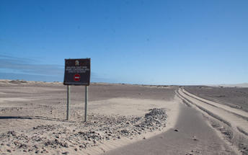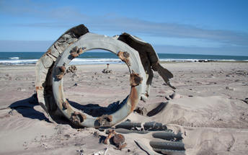

Flight Information
Date | Flight | Airline | Departure Airport | Time | Arrival Airport | Time | Class | Ref
 | Charter |  | Desert Catering - VIP Luxury Tented Camp in Moonlandscape |  | Skeleton Coast Shipwreck Lodge

Basis
Fully Inclusive

Day 6: Skeleton Coast Shipwreck Lodge, Skeleton Coast

Basis
Fully Inclusive

Day 7: Nambwa Tented Lodge, Zambezi Region

Zambezi Region
The Zambezi Region (previously the Caprivi Strip) is the name given to the little finger of Namibia that sticks eastwards between Angola and Botswana all the way across to Zimbabwe and creates the only spot on the planet where 4 countries meet. The region lies in the middle of one of Africa’s largest and most well know game viewing areas. The abundance of water supplied by the Zambezi, Okavango, Kwando and Chobe Rivers sustains a large variety of animal and bird species. There are four Namibian reserves and no fences preventing the animals from moving between the countries.

Overnight: Nambwa Tented Lodge
Nambwa Tented Lodge is within the heart of KAZA and the only lodge uniquely situated inside the Bwabwata National Park. The Lodge offers ten luxurious tents nestled high in the majestic Jackalberry, Sausage and Knobthorn trees. Respecting the elephants' right of way, the lodge is built in exquisite comfort above the African Wildlife. An entirely authentic walkway joins these luxurious tented suites of exquisite comfort, tastefully decorated where natural colors evoke a gentle balance of serenity. The decadently spacious tented suites open completely and emanate a feeling of vastness. From the privacy of your large open-air deck watch the sky illuminate with hues of purple and amber and reenergize for the days adventure ahead.
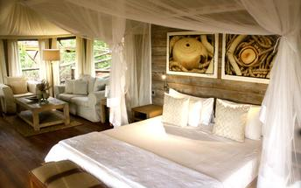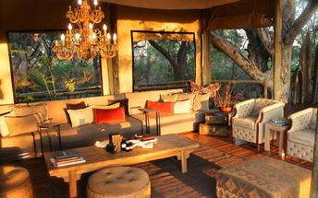

Flight Information
Date | Flight | Airline | Departure Airport | Time | Arrival Airport | Time | Class | Ref
 | Charter |  | Skeleton Coast Shipwreck Lodge |  | Nambwa Tented Lodge

Basis
Fully Inclusive

Day 8: Nambwa Tented Lodge, Zambezi Region

Basis
Fully Inclusive

Day 9: Na'an ku se Lodge, Greater Windhoek

Greater Windhoek
Windhoek, the capital of Namibia, is encircled by magnificent mountains, expansive valleys, fertile farmlands, lodges and luxury guest farms. The landscape of the Greater Windhoek area surrounding this bustling city is characterised by vast valleys, thick scrub, rocky hills, and covered in golden savannah. Visitors can explore the dry river beds and mountainous scrublands, as well as enjoy birding, leopard-spotting and view large quantities of wildlife in the north; visit the more arid eastern part with its olive, potato and date plantations; explore the rolling hills of the Khomas Hochland Mountains in the west of the Greater Windhoek area and soak up the epic views along a number of scenic passes leading off the high plateau including: Bosua Pass, Gamsberg Pass and Spreetshoogte Pass.

Day Itinerary
Charter flight will take you to the Hosea Kutako International Airport and there you will be transferred by road to Na ankuse Lodge.

Consultant Notes
No Notes Available

Overnight: Na'an ku se Lodge
Join us for a luxury break amid the stunning African Savannah. Located just thirty minutes from Windhoek International Airport and nestled in the stunning African bush fields, our Lodge is perfectly situated to start or finish your trip to Namibia. With a range of enjoyable activities available, including Carnivore Feeding Tours and Cheetahs Up Close you are sure to enjoy an unforgettable African holiday with us. The only charity lodge in Namibia, N/a’an ku sê Lodge is crafted from ecologically clean material including solid logs and glass to complement N/a’an ku sê’s beautiful wilderness setting. Guests will find six luxurious, individual chalets and a tranquil dining area with stunning views, bar and swimming pool. There are also five beautifully appointed and fully equipped holiday houses available for hire. The Lodge also provides a breathtaking backdrop for weddings and conferences. Our Lodge is a not for profit eco-tourism destination, where all profits are directed straight back into supporting our charitable projects.
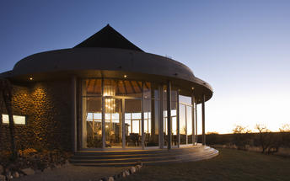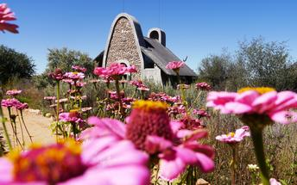

Flight Information
Date | Flight | Airline | Departure Airport | Time | Arrival Airport | Time | Class | Ref
 | Charter |  | Nambwa Tented Lodge |  | Hosea Kutako International Airport

Basis
Dinner, Bed and Breakfast

Day 10: End of Itinerary

Transfers
Date | Company | Pick Up | Drop Off | Time | Vehicle
 |  | Na'an ku se Lodge | Hosea Kutako International Airport [WDH] |  | Transfer

Basis
Bed & Breakfast

